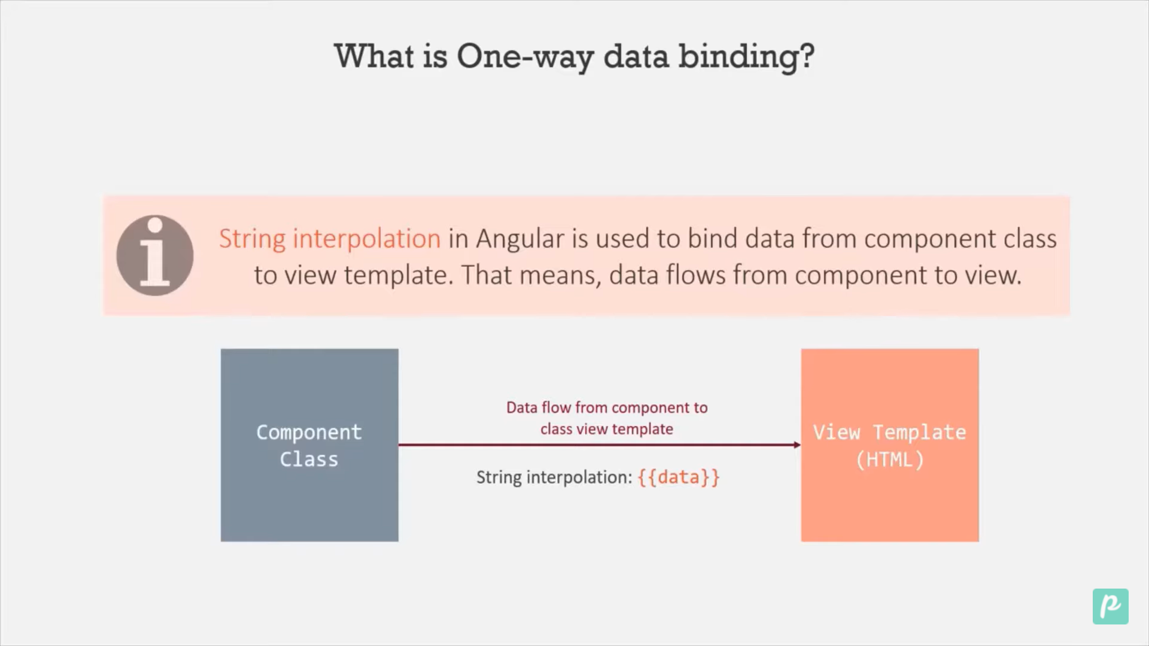

export class HeaderComponent {

  slogan: string = 'Welcome to Angular Basic content';

Here we create a slogan as a variable which can be used in view template, we can use it by {{name}}.

</div>

<h1>{{ slogan }}</h1>

<app-notification></app-notification>

{{ 12+34+%6-90}}: We can perform arithmetic operation also.

We can pass method also.

Create method in .ts class and call from view template

getFirstSlogan()

  {

    return "Angular Class"

  }

In view template

<h2>{{ getFirstSlogan()}}</h2>

Property Binding

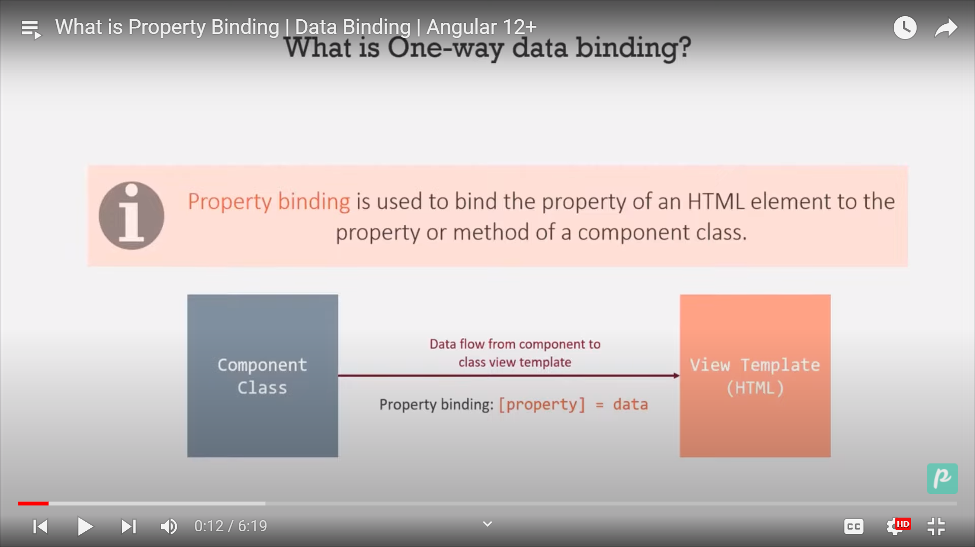

<!-- Property Binding -->

<img

  src="/assets/sonu.jpg"

  alt="Good Morning Friends"

  height="240"

  width="300"

/>

Here in src we are directly assign the value.

Now we will use property binding to assign the value.

<!-- Property Binding -->

<img [src]="source" alt="Good Morning Friends" height="240" width="300" />

And in header.component.ts weh have to specify this

 source: string = '/assets/sonu.jpg';

Now the code is for class

import { Component } from '@angular/core';

@Component({

  selector: 'app-header',

  templateUrl: './header.component.html',

  styleUrls: ['./header.component.css'],

})

export class HeaderComponent {

  slogan: string = 'Welcome to Angular Basic content';

  getFirstSlogan() {

    return 'Angular Class';

  }

  source: string = '/assets/sonu.jpg';

}

Now the code is for html

  <div class="header-right">

    <a class="active" href="#home">Home</a>

    <a href="#contact">Contact</a>

    <a href="#about">About</a>

  </div>

</div>

<!-- This is String interpolation -->

<h1>{{ slogan }}</h1>

<h2>{{ getFirstSlogan() }}</h2>

<!-- Property Binding -->

<img [src]="source" alt="Good Morning Friends" height="240" width="300" />

<app-notification></app-notification>